Yara Arts Group & the Ukrainian Educational and Cultural Center present:
Yara’s Theatre Projects:
Poetry as Theatre: Oleh Lysheha’s Swan

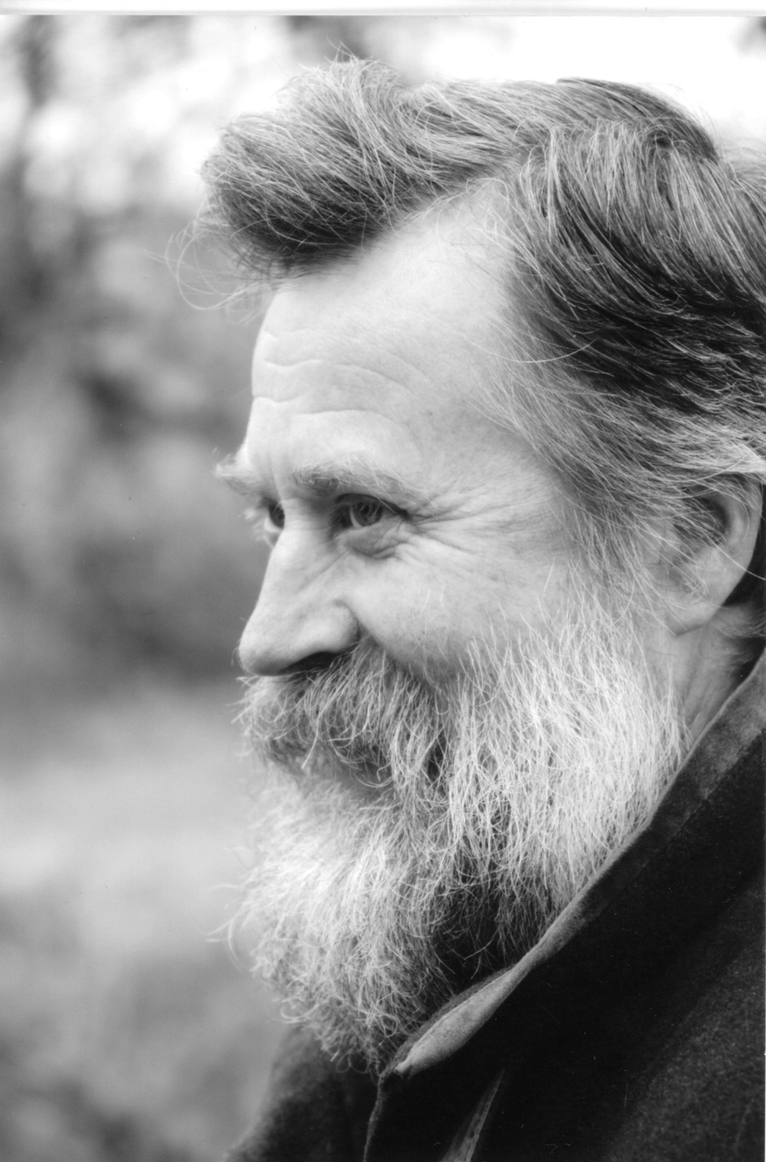

Premiere June 25, 2020
www.yaraartsgroup.net
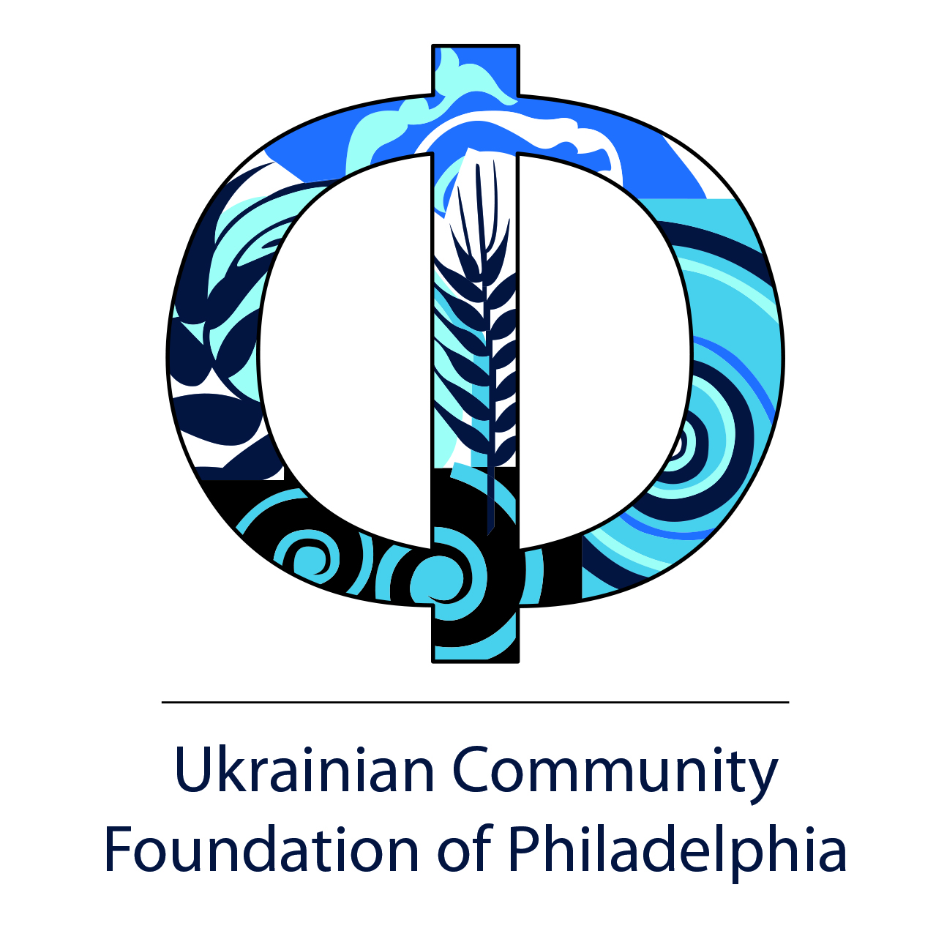
Yara Arts Group & the Ukrainian Educational and Cultural Center present:
Yara’s Theatre Projects
Poetry as Theatre: Oleh Lysheha’s Swan

Entrance audio: Oleh Lysheha reading the first three parts of “Swan”

Introductions: Virlana Tkacz

On Oleh Lysheha in Tysmenytsia: photos by Waldemart Klyuzko

Lysheha in Lviv, Buryatia, Kyiv and US: Virlana Tkacz

Translating Oleh Lysheha & his poem “Song 212:” Wanda Phipps

Lysheha works with Yara Arts Group
“Swan” at Yara’s Theatre Workshops at Harvard - Virlana & Wanda
“Swan” in Virtual Souls - Cecilia Arana-Grant
“Swan” in Flight of the White Bird – Meredith Wright

Yara’s SWAN (2003) at La MaMa
Andrew Colteaux
Soomi Kim
Paul Brantley
Meredith Wright and Olga Shuhan

Audio: Oleh Lysheha reading part nine of “Swan”

The Swan Appears: Andrea Odezhynska and Watoku Ueno

Exit audio: Oleh Lysheha reading last parts of “Swan”
Oleh Lysheha recorded by Yuriy Kucheriavy

virtual event directed by Virlana Tkacz
visual design: Waldemart Klyuzko
tech support: Darien Fiorino

OLEH LYSHEHA was born in 1949 near the Carpathian Mountains in Ukraine and studied English at the University of Lviv, where he began translating American poetry. Expelled from school during the purges in 1972 for contributing to journal Skrynia (The Chest), he was sent to do military duty in Siberia in the Buryat Republic. Returning, Lysheha settled in Kyiv and worked on his poetry, while holding menial jobs. His first collection, The Great Bridge (1989), was truly different from everything published in Soviet Ukraine. In 1994 Lysheha published the poem “Swan” and Yara incorporated the poem into its Harvard Theatre Workshop the following summer. Then fragments of the poem were in Yara’s shows Virtual Souls (1997) and Flight of the White Bird (1999) at La MaMa and the Buryat National Theatre in Ulan Ude. In 1999 the poem was published in a bilingual collection The Selected Poems of Oleh Lysheha (Harvard University), in translations by the author and James Brasfield. The book was awarded the PEN Translation Prize. Lysheha’s other collections of poetry included Winter in Tysmenytsia and To Snow and Fire. Lysheha died in 2014 at the age of 65 in Kyiv. Virlana Tkacz
ANDREW COLTEAUX (performer) created the part of Vasyl Yeroshenko in Yara Arts Group’s Blind Sight and performed it in Kharkiv, Kyiv and in New York at La MaMa. He also appeared in Yara’s Forest Song, Swan, The Warrior’s Sister, Raven and Dream Bridge. which performed in Lviv, Kyiv, Bishkek and at La MaMa. A native of northern California, he is glad to be back in Marin County.
SOOMI KIM (performer) created a trilogy of hybrid plays inspired by Asian American visionaries, whose lives were cut short. "Chang(e)" (2015, based on Kathy Change, a political activist and performance artist), "Dictee: bells fall a peal to sky" (2012- adaptation of Theresa Hak Kyung Cha’s DICTEE) and "Lee/gendary" (2008, based on Bruce Lee and 3 NYITA wins).
PAUL BRANTLEY (composer and cellist) is a five time MacDowell Colony Fellow with recent performances of his music by The Knights (at Tanglewood, BRIC, Dumbarton Oaks and Naumburg Central Park Concerts), Horszowski Trio, Flux Quartet, New Esterhâzy Quartet, Bridgehampton Chamber Music Festival, Young People's Chorus of NYC, Philharmonic Orchestra of the Americas, and ETHEL/Todd Rundgren. His music is published by Bill Holab.
OLGA SHUHAN (Ukrainian voice) has worked with Yara on the shows A Light from the East and Explosions, as well as numerous poetry readings. She was in the original New York cast of Ping Chong’s Undesirable Elements.
MEREDITH WRIGHT (vocals) is the songbird you don't see in Swan. She was seen in Yara's Circle Flight of the White Bird, Song Tree and Howling. Swan is dedicated to her toddler friends who still enjoy spinning and spinning until they fall down, or maybe fly!
CECILIA ARANA GRANT (performer) first worked with Yara on Waterfall/Reflections with Nina Matvienko, she then appeared with the Buryat artists in Virtual Souls and worked with Nina, her daughter Tonia and the Kyrgyz artists Kenzhe and Ainura in Scythian Stones at La MaMa and in Kyiv.
WATOKU UENO (designer) came to La MaMa in 1982 and worked on projects with Ping Chong, Ubu Rep and David Rousseve. He has also worked in New York theatres and internationally in Asia, Siberia and Eastern Europe. He is a founding member of the Yara Arts Group and has worked on almost every Yara show from its conception to its final production.
VIRLANA TKACZ (director/co-translator) heads the Yara Arts Group and has directed over thirty original shows at La MaMa Theatre in New York, as well as in Kyiv, Lviv, Kharkiv, Bishkek, Ulaanbaatar, and Ulan Ude. She received an NEA Poetry Translation Fellowship for her translations with Wanda Phipps.
WANDA PHIPPS (co-translator) is a founding member of Yara and has been translating Ukrainian poetry with Virlana Tkacz since 1989. Together they have received the Agni Review Poetry Award and the National Theatre Translation Award, as well as several grants from the New York State Council on the Arts.
ANDREA ODEZYNSKA (video) has directed award winning short films, which have aired on Showtime and Bravo and played in numerous film festivals. She created the video for Yara's Circle, Obo: Our Shamanism, Howling, Song Tree, Swan and Still the River Flows. Her documentary films include “The Whisperer” and “Felt, Feelings and Dreams.”
WALDEMART KLYUZKO is an artist from Kyiv who has collaborated with Yara Arts Group since 2010, most recently creating the set for Opera GAZ. He is a visual artist who has had exhibits at La MaMa Galleria, the Ukrainian Institute of America and the Bezpala Gallery in Toronto.
DARIEN FIORINO is at Cornell University studying environmental science and performing arts. He was in Yara’s Winter Songs on Mars and 1917/2017: Tychyna, Zhadan, and the Dogs at La MaMa.
YARA ARTS GROUP was established in 1990 and is a resident company at La MaMa, the acclaimed experimental theater in New York. Yara has created thirty-seven theatre pieces based on extensive research in Eastern Europe, Siberia and Asia, in Yara’s signature style of multilingual dialogue and songs supported by evocative visuals. Yara Arts Group 306 East 11th St #3B, New York, NY 10003 (212)475-6474 www.yaraartsgroup.net
Yara’s Virtual Events were made possible by The Ukrainian Community Foundation of Philadelphia, Ukrainian SelfReliance FCU, public funds from New York State Council on the Arts and contributions from the friends of Yara Arts Group.

