THE MAGIC OF LIGHT
Created by Virlana Tkacz, Julian Kytasty & Tom Lee
Puppeteer/performer: Tom Lee
Music composer/performer: Julian Kytasty
Directed by Virlana Tkacz
Music composed & performed by Julian Kytasty
Puppetry by Tom Lee
Production designed by Tom Lee & Andreea Mincic
Shadow puppet design & video by Linda Wingerter
Puppet design & carving by Kevin White
Lighting design by Kat C. Zhou
Translations by Virlana Tkacz & Wanda Phipps
Assistant puppeteer: Zlata Godunova
Intern assistant to designers: Caitlin Nugent
Assistant to designers: Jacky Kelsey
Stage manager: Erin Gray
Assistant director: Olenka Tsyhankova
Sound: Nadia Othman
Research: Nadia Sokolenko
Graphics by Waldemart Klyuzko

March 7-16, 2025, Downstairs Theatre
La MaMa Experimental Theatre 66 E 4 St NYC

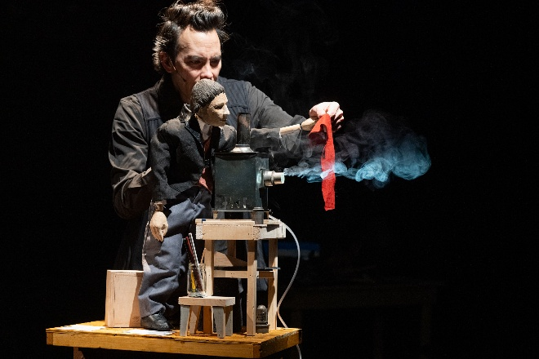

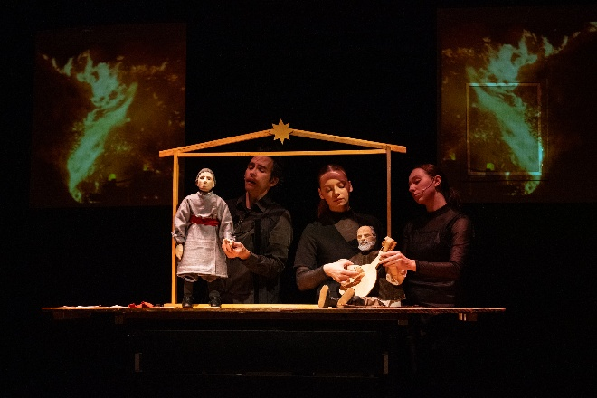
Photos by Pavlo Terekhov
Press in New York
“The Yara Arts Group, in residence at La Mama E.T.C., is producing an exquisite… complex seventy-minute, multi-media show through March 16th in La Mama’s Downstairs theater… It showcases spoken-word theater and poetry, instrumental music (on the ancient Ukrainian bandura… used to accompany oral epics) songs, puppetry (both rod puppets and shadow puppets), videos, and, of course, delicate effects of lighting.
…The events concern a historic concert in an opera house of the Russian empire during 1875, in which inherited oral epics of Ukraine were introduced to a cosmopolitan audience by the blind singer Ostap Versai (1803—1890), who accompanied himself on the bandura…
Versai’s renditions of the epics were accompanied by magic-lantern projections of impressively skillful pencil portraits of Ukrainian figures, made by the art student Porfiry Martynovych (1856—1933), the protagonist of The Magic of Light. Copies of some of those drawings are projected at La Mama, too…” The tsar at the time, [made] it illegal to speak Ukrainian or to practice the culture of the region... The epic song we hear Julian Kytasty as Versai sing with his bandura is “How Three Brothers Escaped from the Fortress called Azov”… takes no prisoners in its account of hard choices…
The content of this production is sobering and unflinching. But the puppets who serve as the messengers of that content are spellbinding vessels of delight. The shadow puppets are relatively simple, but the rod puppets are activated, as in Japanese bunraku puppet theater... The Yara puppets are much smaller than bunraku ones, and so, in the Yara production, each puppet is energized by one puppeteer… The marvelous individuation of the heads and long-fingered hands (conceived by Tom Lee, carved by Kevin White) and the doubling of some characters, presented in different sizes to give changing perspectives on them in the unscrolling narrative, is mesmerizing...”
Mindy Allof, New York Theatre Wire, March 12, 2025 - https://nytheatre-wire.com/ma25031t.htm
“How would you feel were your language forbidden, your culture replaced, possessions annexed, history rewritten? Two out of four of these can be experienced currently in America, but so far not to the extreme of persecution and loss in Ukraine.
1875. Young Porfiry Martynovych (1856-1933), an 12” puppet, leaves for the Imperial Art Academy in St. Petersburg. He waves to beekeeper Pavlo (actor/bandura master Julian Kytasty) who plays and sings. We see both the human and puppet persona. “Oh once there was freedom across steppe/And now there is no freedom…”
Martynovych is a skilled artist whose preferred subjects are realistic depictions of the commoners. He’s drawn to classic songs by blind storytellers who carry on oral history and fading tradition. When a noted composer asks him (shadow puppets depict) to illustrate an “epic concert” with projections of his drawings, the young man is excited.
“… To look at the very far moon and the stars- you need a telescope. But to create a scene you’ve never seen before, all you need is light in the dark…” A larger version- 18”- of Martynovych (actor/puppeteer Tom Lee) speaks beside a model magic lantern. Lee is marvelous. Every word and expression reflect that of his alter ego.
Not only might the young man’s art be accepted at last, Ostap Veresai, called the Homer of Ukraine, is to be the performer. Curtain rises on a beautifully appointed theater. Cardboard audience attends. The well-known program consists of “How Three Brothers Escaped from the Fortress Called Azov”:
Siblings escape a Turkish fortress with only two horses. The third boy is left to follow – should he survive pursuit.
The concert’s reception seems positive, but the streets reveal prejudice: “Those Ukrainians – who do they think they are?.. We must demand strict official censorship…” When the painter finally manages to get two works in an exhibition, his art is condemned as… “outside the classical cannon, way below our standards.”
Atop the theater, an extravagantly dressed 12’’ Tsar declares that “Ukraine never existed, does not exist and shall never exist…” The hero despairs and moves to a small village where he paints what he wants. Traveling, he meets more epic singers, seeding hope.
The last song by contemporary poet Serhiy Zhadan with music by Julian Kytasty is accompanied by modern photos of war. Without political rhetoric, volume, or violence, Yara Arts Group communicates the struggle and endurance of a proud people-deserving aid who serve as warning. History repeats itself. We too should be afraid…”
Alix Cohen, Woman Around Town, March 17, 2025 https://www.womanaroundtown.com/sections/playing-around/the-magic-of-light-a-cry-from-ukraine/

“While American and European newspapers are providing daily news about the present Russian aggression and decimation of an entire nation whose legitimate independent existence is being denied, the people’s spirit at home and abroad finds sustenance in its cultural traditions. The latest offering by the Yara Arts Group under the founding leadership of Virlana Tkacz connects to this spirit and fulfills a mission by unearthing and presenting the work of artists that have shaped Ukrainian consciousness and sensibility… The Magic of Light brings to light the achievements of artists from the 1860s and 70s whose works in painting and music were showcasing the traditional forms of Ukrainian culture found among the peasants, in myths and legends often transmitted orally by kobzars, the wandering minstrels who traversed the Ukrainian steppes, accompanying themselves with a traditional Ukrainian string instrument, the bandura.
Virlana Tkacz has once again collaborated with the superb bandura master musician/performer Julian Kytasty whose singing/reciting and strumming brings to life the text with dialogue among the various characters, the poetry, and various traditional songs, most centrally among them the tragic epic, “How Three Brothers Escaped from the Fortress called Azov.” Julian Kytasty is channeling the spirit of the blind popular kobzar Ostap Veresai (1803-1890) who traversed Ukraine and performed at the 1875 Salt Palace Concert which was organized for Veresai by the well-known composer, pianist and conductor Mykola Lysenko... The Magic of Light production weaves together dialogue, poetry, and music in a richly entertaining performance.
A major visual and performance component is a special kind of puppetry art that combines hand-held puppets with a visible puppeteer/actor whose hands, facial expression and voice gives the puppet the emotional dimension of the character. Tom Lee is the puppeteer/actor who brings to life the central character/puppet, the painter Porfiry Martynovych (1856-1933), whose drawings were projected by the magic lantern during the Ostap Veresai concert at The Salt Palace.
Tom Lee’s fine artistry—he is a master of various puppetry traditions and video projection designs—is critical to making the puppet human, as he gently moves the puppet with his hands, his visible face and clear voice carrying the wide range of emotions from humor to dejection. Black and white shadow puppets, designed by Linda Wingerter and projected against a backdrop take over at certain points the lively action in the narration of the life of Porfiry Martynovych and his encounters with influential personalities, all represented by hand puppets that have been beautifully carved and designed by Kevin White with realistic individual features and clothing…
Beate Hein Bennett March 8, 2025, in the New York Theatre Wire
https://nytheatre-wire.com/25031t.htm

“The puppets move across the stage, aided by actors, in slow motion, pushing through the sometimes-heavy notes of the bandura played by master Julian Kytasty creating an unforgettable scene. The performance of The Magic of Light by Yara Arts Group at La MaMa March 7-16 combined elements of folk songs, poetry, history, and puppetry that brought Ukraine to light in these challenging times.
The puppets were meticulously designed by Tom Lee and he served as the puppeteer for all of them. As he recited the English-language lines of the show, his voice rang out with clarity. His body was unobtrusive as he moved the puppets with incredible care. The puppets were an amazing artistic achievement. They were carved by Kevin White and dressed by Andrea Mincic. Their beautifully created faces were brought to life by Tom Lee’s puppeteering.
In Ukrainian, Julian Kytasty echoed the character of Ostap Versai (1803-1890,) a blind epic singer, who was present as a puppet. Their hands on the banduras made similar motions. The worlds of the puppets and humans merged. History and the present were brought together, drawing past events into the present.
The epic that Kytasty/Versai sings is “How Three Brothers Escaped from the Fortress Called Azov.” A story within the main story of the show about three brothers who escape from captivity in the fortress of Azov, two on horse and one on foot.
The puppet Profiry Martynovych (1856-1933) was the main character of the show. He created the drawings for the Magic Lantern projections for Ostap Versai’s 1875 concert. The projections in the show were beautiful and disturbing, from shadow puppets to images of the war in Ukraine and the Los Angeles wildfires.
Splashes of color stand out in the show. There is the red piece of silk that the older brothers left for the younger brother. There is the bright Ukrainian flag waving during the curtain call. In addition, the box of light above the stage where the puppet Ostap Versai sits stands out.
The show reminds us of history. There is a song, “The Tsar’s Ems Decree, 1876,” that recites the actual details of the decree that banned Ukrainian language, performances and books.
The calling bird puppet was remarkable and carried by Zlata Godunova to the stunning final song “Light,” with music by Julian Kytasty. Zlata’s body moves across the stage like a shadow puppet herself. The darkness of her clothing flows through the magic of light.
In this piece as in Serhiy Zhadan’s poem “Light” that creates the final song translated into English by Virlana Tkacz and Wanda Phipps, language comes to life with the name of the land. It reminds us of the power of poetry and theater. In performances such as this one, we remember the importance of keeping our thoughts with Ukraine.
The Magic of Light is going on the road in November and will be in Chicago at Northwestern University’s Wirtz Theatre November 13-16.
Olena Jennings Our Life, August 2025

“A fascinating performance piece presented by La MaMa ETC and Yara Arts Group, “The Magic of Light” reflects on the history of Ukraine utilizing several parallel stories in various timelines that eventually intertwine for emotional impact.
This production utilized live actors and puppets, video, music and movement… so that we see the real-life performers, such as the excellent musician, Julian Kytasty, reflected in puppet mirror images. A great many artists contributed to this tale of friendships, betrayal, politics, prejudice and artistic obsession.
The show was created in rehearsal by director Virlana Tkacz, Kytasty (who besides singing and playing the bandura, composed the music), and puppeteer-performer Tom Lee.
Kevin White, Andreea Mincic, Linda Wingerter and Kat C. Zhou contributed with creative designs that added immeasurably to the program. The physical aspects of the show told the story as much as the words: the dismantling of a puppet theater, for instance, was emotionally devastating….
Bart Greenberg, nitelifeexchange, March 24, 2025 https://nitelifeexchange.com/the-magic-of-light-and-a-measure-of-darkness-in-19th-century-ukraine/

